Please follow these instructions to activate WJ-ASM-300 Lite.

WJ-ASM300 installation: Create a restore point in Windows first just in case you need it.

Install WJ-ASM300 and get the MPR ID number. The icon for the software looks like this after installation 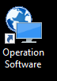

DO NOT Load the demo version code. If the demo version is activated, you CANNOT change to the Light version.

For light version, go to the Panasonic Key Management site at the following:

https://kms.business.panasonic.net/ipkms/pc/home.htm

Register using your MPR ID obtained from the steps above and these activation numbers.

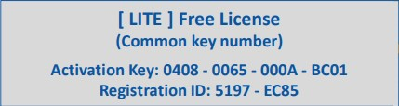
Your MPR ID along with the Activation Key and the Registration ID on the Panasonic site above will generate an Registration Key…..This Registration Key is what you will type into the ASM300 on your computer to activate a copy of ASM300 Light

